NEW SUMMIT COLLEGE

(Affiliated to Tribhuvan University)



Lab Report on

Design and Analysis of Algorithms

CSC314
Bachelor of Science in Computer Science and Information Technology
Institute of Science and Technology

Submitted by: Submitted to:
Name: Ritu Dhakal Instructor: Bhupendra Saud
Bsc.CSIT 5th semester New Summit College
Roll.no: 80010549


NEW SUMMIT COLLEGE

Subject: Design and Analysis of Algorithms
Submitted by: Ritu Dhakal

INDEX
S.N | Objective | Practical Date | Submission Date and signature
1. | Write a program in c to find time complexity of Bubble sort by using RAM Model.
2. | Write a program in c to find time complexity of Insertion sort by using RAM Model.
3. | Write a program in c to find time complexity of Insertion sort by using RAM Model.
4. | Write a program in c to find GCD of given two numbers.
5. | Write a program in c to sort given numbers by using merge sort and find execution time by using clock function.
6. | Write a program in c to sort given numbers by using Quick sort and find execution time by using clock function.
7. | Write a program in c to sort given numbers by using Heap sort and find execution time by using clock function.

S.N | Objective | Practical Date | Submission Date and signature
8. | Write a program in c to sort given numbers by using Randomized Quick sort and find execution time by using clock function.
9. | Write a program in c to sort optimal multiplication cost of given matrices.
10. | Write a program in c to sort sequences of jobs and their cost by using job sequencing with deadline.
11. | Write a program in c to find maximum profit by using 0/1 knapsack problem.
12. | Write a program in c to find path compression of given text file by using Huffman algorithm.
13. | Write a program in c to find shortest path by using Floyd warshall algorithm (all pair).
14. | Write a program in c to find shortest path by using Dijkstra’s algorithm (single source).
15. | Write a program in c to find spanning tree of given graph by using Kruskal’s Algorithm.
S.N | Objective | Practical Date | Submission Date and signature
16. | Write a program in c to find spanning tree of given graph by using Prims algorithm.
17. | Write a program in c to find max and min value from given data set by using min-max algorithm.
18. | Write a program in c to select i^{th} smallest element by using selection in expected linear time algorithm.
19. | Write a program in c to select subset sum by using backtracking.
20. | Write a program in c to select simulate N-queen problem by using backtracking.

- Write a program in c to find time complexity of Bubble sort by using RAM Model.
Source code:
#include <stdio.h>
int main() {
int a[100], n, i, j, temp;
int count = 0; // To count operations (RAM model)
printf("\\By Ritu Dhakal\n");
printf("Enter number of elements: ");
scanf("%d", &n);
count = count+6;
printf("Enter elements:\n");
for(i = 0; i < n; i++) {
scanf("%d", &a[i]);
count++; // input operation
}
// Bubble Sort
for(i = 0; i < n-1; i++) {
count++; // loop check
for(j = 0; j < n-i-1; j++) {
count++; // comparison
if(a[j] > a[j+1]) {
temp = a[j];
a[j] = a[j+1];
a[j+1] = temp;
count += 3; // swap operations
}
}
}
count = count+2;
printf("Sorted array:\n");
for(i = 0; i < n; i++) {
count++;
printf("%d ", a[i]);
}
count = count+3;
printf("\nTotal RAM operations = %d\n", count);
printf("Time Complexity of Bubble Sort = O(n^2)");
return 0;
}

Output
Input / Output 1:
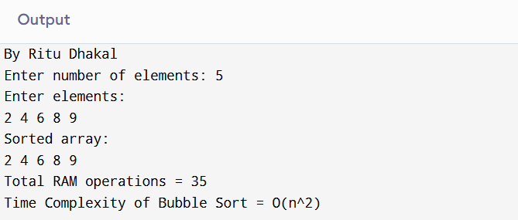
Input / Output 2:
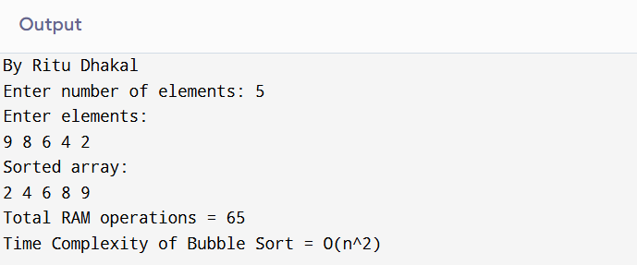
Input / Output 3:
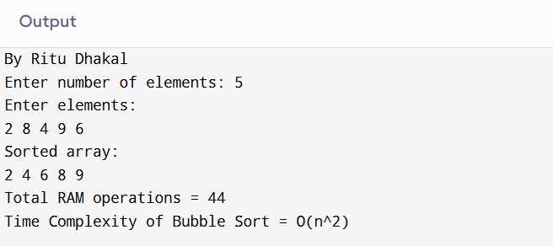

- Write a program in c to find time complexity of Insertion sort by using RAM Model.
Source code:
#include <stdio.h>
int main() {
int a[100], n, i, j, key;
int count = 0;
printf("Ritu Dhakal\n");
printf("Enter number of elements: ");
scanf("%d", &n);
count += 3;
printf("Enter elements:\n");
for(i = 0; i < n; i++) {
scanf("%d", &a[i]);
count++;
}
// Insertion Sort
for(i = 1; i < n; i++) {
key = a[i];
j = i - 1;
count += 2;
while(j >= 0 && a[j] > key) {
a[j+1] = a[j];
j--;
count += 2;
}
a[j+1] = key;
count++;
}
printf("Sorted array:\n");
for(i = 0; i < n; i++) {
printf("%d ", a[i]);
count++;
}
printf("\nTotal RAM operations = %d\n", count);
printf("Time Complexity of Insertion Sort = O(n^2)");
return 0;
}

Output
Input / Output 1:
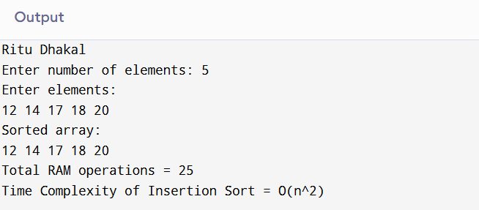

Input / Output 2:
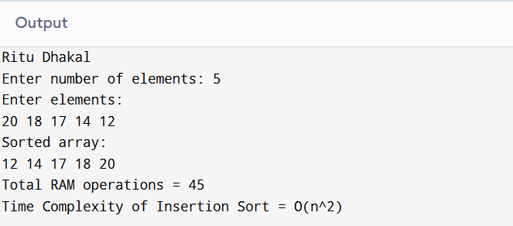
Input / Output 3:
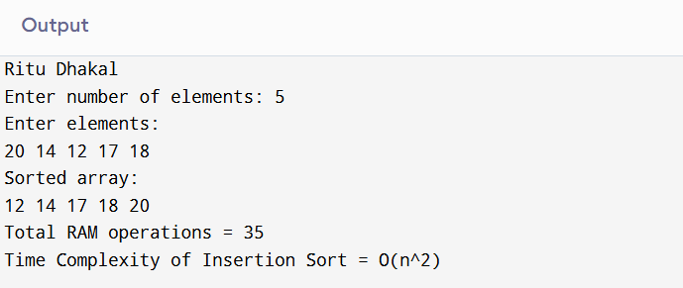

- Write a program in c to find time complexity of Insertion sort by using RAM Model.
Source Code:
#include <stdio.h>
int main() {
int a[100], n, i, j, min, temp;
int count = 0;
printf("Ritu Dhakal \n");
printf("Enter number of elements: ");
scanf("%d", &n);
count += 3;
printf("Enter elements:\n");
for(i = 0; i < n; i++) {
scanf("%d", &a[i]);
count++;
}
// Selection Sort
for(i = 0; i < n-1; i++) {
min = i;
count++;
for(j = i+1; j < n; j++) {
count++;
if(a[j] < a[min]) {
min = j;
count++;
}
}
temp = a[i];
a[i] = a[min];
a[min] = temp;
count += 3;
}
printf("Sorted array:\n");
for(i = 0; i < n; i++) {
printf("%d ", a[i]);
count++;
}
printf("\nTotal RAM operations = %d\n", count);
printf("Time Complexity of Selection Sort = O(n^2)");

return 0;
}

Output
Input / Output 1:
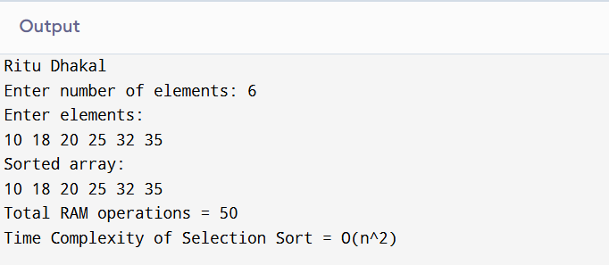

Input / Output 2:
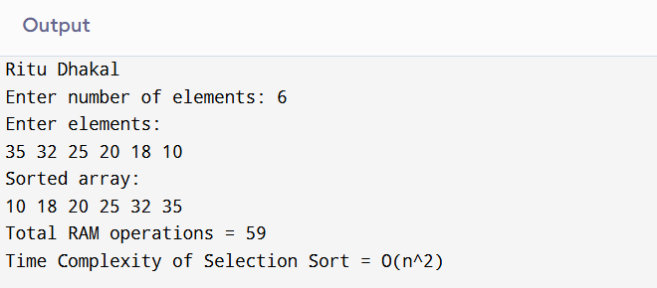

Input / Output 3:
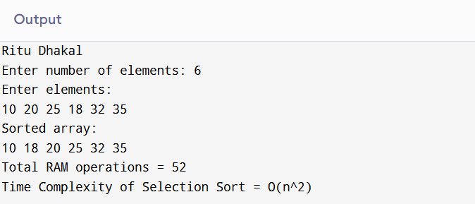
- Write a program in c to find GCD of given two numbers.
Source Code:
#include <stdio.h>
int main() {
int a, b, temp;
int count = 0; // RAM operation counter
printf("By Ritu Dhakal\n");
printf("Enter two numbers: ");
scanf("%d %d", &a, &b);
count += 3;
// Euclidean Algorithm
while(b != 0) {
count++; // loop check
temp = b;
b = a % b;
a = temp;
count += 3; // assignment operations
}
count++;
printf("GCD = %d\n", a);
printf("Total RAM operations = %d\n", count);

return 0;
}

Output:
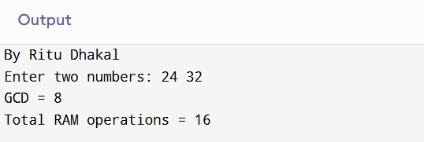

- Write a program in c to sort given numbers by using merge sort and find execution time by using clock function.
Source code:
#include <stdio.h>
#include <time.h>
void merge(int arr[], int left, int mid, int right)
{
int i, j, k;
int n1 = mid - left + 1;
int n2 = right - mid;
int L[n1], R[n2];
// Copy data to temporary arrays
for(i = 0; i < n1; i++)
L[i] = arr[left + i];

for(j = 0; j < n2; j++)
R[j] = arr[mid + 1 + j];
i = 0;
j = 0;
k = left;
// Merge the temp arrays
while(i < n1 && j < n2)
{
if(L[i] <= R[j])
{
arr[k] = L[i];
i++;
}
else
{
arr[k] = R[j];
j++;
}
k++;
}
// Copy remaining elements
while(i < n1)
{
arr[k] = L[i];
i++;
k++;
}
while(j < n2)
{
arr[k] = R[j];
j++;
k++;
}
}
void mergeSort(int arr[], int left, int right)
{
if(left < right)
{
int mid = (left + right) / 2;
mergeSort(arr, left, mid);
mergeSort(arr, mid + 1, right);
merge(arr, left, mid, right);
}
}
int main()
{
int arr[100], n, i;
clock_t start, end;
double cpu_time_used;
printf("By Ritu Dhakal\n");
printf("Enter number of elements: ");
scanf("%d", &n);
printf("Enter elements:\n");
for(i = 0; i < n; i++)
scanf("%d", &arr[i]);
start = clock(); // Start time
mergeSort(arr, 0, n - 1);

end = clock(); // End time
printf("Sorted array:\n");
for(i = 0; i < n; i++)
printf("%d ", arr[i]);
cpu_time_used = ((double)(end - start)) / CLOCKS_PER_SEC;
printf("\nExecution Time: %f seconds\n", cpu_time_used);
return 0;
}

Output:
Input / Output 1:
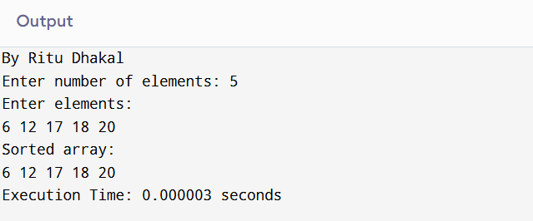
Input / Output 2:
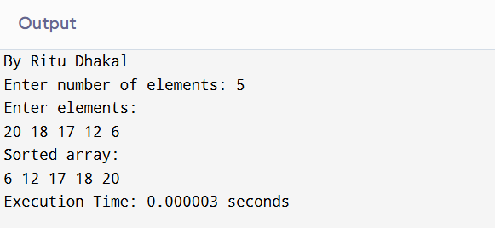

Input / Output 3:
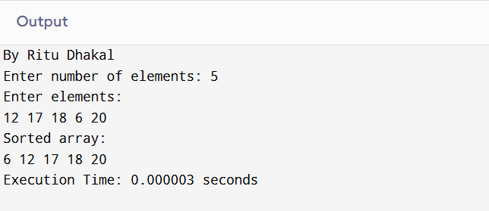

- Write a program in c to sort given numbers by using Quick sort and find execution time by using clock function.
Source Code:
#include <stdio.h>
#include <time.h>
void swap(int *a, int *b)
{
int temp = *a;
*a = *b;
*b = temp;
}
int partition(int arr[], int low, int high)
{
int pivot = arr[high]; // Choose last element as pivot
int i = low - 1;
int j;
for(j = low; j < high; j++)
{
if(arr[j] < pivot)
{
i++;
swap(&arr[i], &arr[j]);
}
}
swap(&arr[i + 1], &arr[high]);
return i + 1;
}
void quickSort(int arr[], int low, int high)
{
if(low < high)
{
int pi = partition(arr, low, high);
quickSort(arr, low, pi - 1);
quickSort(arr, pi + 1, high);
}
}
int main()
{
int arr[100], n, i;
clock_t start, end;
double cpu_time_used;
printf("By Ritu Dhakal\n");
printf("Enter number of elements: ");
scanf("%d", &n);
printf("Enter elements:\n");
for(i = 0; i < n; i++)
scanf("%d", &arr[i]);
start = clock(); // Start time
quickSort(arr, 0, n - 1);
end = clock(); // End time
printf("Sorted array:\n");
for(i = 0; i < n; i++)
printf("%d ", arr[i]);
cpu_time_used = ((double)(end - start)) / CLOCKS_PER_SEC;
printf("\nExecution Time: %f seconds\n", cpu_time_used);
return 0;
}

Output:
Input / Output 1:
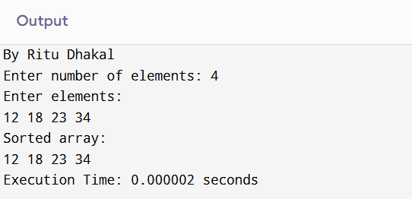
Input / Output 2:
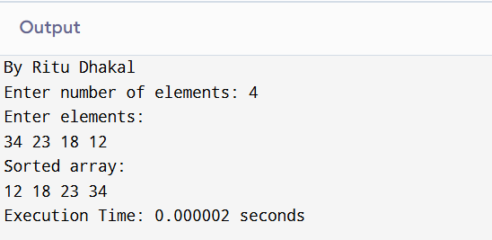
Input / Output 3:
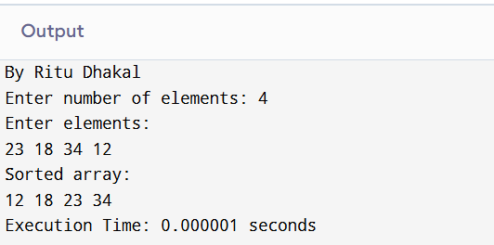

- Write a program in c to sort given numbers by using Heap sort and find execution time by using clock function.
Source code:
#include <stdio.h>
#include <time.h>
void swap(int *a,int *b){
int t=*a;*a=*b;*b=t;
}
void heapify(int a[],int n,int i){
int largest=i,l=2*i+1,r=2*i+2;
if(l<n&&a[l]>a[largest]) largest=l;
if(r<n&&a[r]>a[largest]) largest=r;
if(largest!=i){
swap(&a[i],&a[largest]);heapify(a,n,largest);
}
}
void heapSort(int a[],int n){
int i;
for(i=n/2-1;i>=0;i--) heapify(a,n,i);
for(i=n-1;i>0;i--){
swap(&a[0],&a[i]);heapify(a,i,0);
}
}
int main()
{
int a[100],n,i;clock_t s,e;double t;
printf("By Ritu Dhakal\n");
printf("Enter number of elements: ");
scanf("%d",&n);
printf("Enter elements:\n");
for(i=0;i<n;i++) scanf("%d",&a[i]);
s=clock();
heapSort(a,n);
e=clock();
printf("Sorted array:\n");
for(i=0;i<n;i++) printf("%d ",a[i]);
t=(double)(e-s)/CLOCKS_PER_SEC;
printf("\nExecution Time: %f seconds\n",t);
return 0;
}

Output:
Input / Output 1:
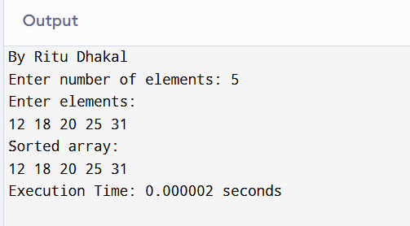
Input / Output 2:
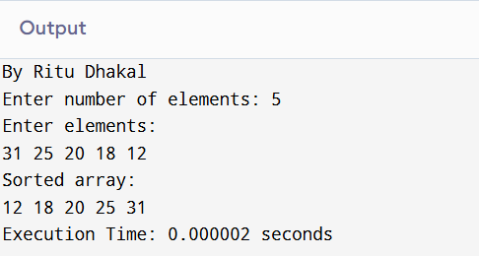
Input / Output 3:
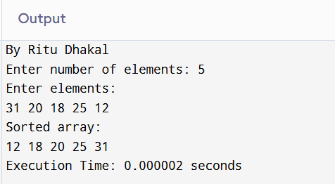

- Write a program in c to sort given numbers by using Randomized Quick sort and find execution time by using clock function.
Source Code:
#include <stdio.h>
#include <time.h>
#include <stdlib.h>
void swap(int *a,int *b){
int t=*a;*a=*b;*b=t;}
int partition(int a[],int l,int h){
int p=a[h],i=l-1,j;
for(j=l;j<h;j++) if(a[j]<p) swap(&a[++i],&a[j]);
swap(&a[i+1],&a[h]);
return i+1;
}
int randPart(int a[],int l,int h){
int r=l+rand()%(h-l+1);
swap(&a[r],&a[h]);
return partition(a,l,h);
}
void rqSort(int a[],int l,int h){
if(l<h){
int pi=randPart(a,l,h);
rqSort(a,l,pi-1);
rqSort(a,pi+1,h);
}}
int main(){
int a[100],n,i;clock_t s,e;double t;
printf("By Ritu Dhakal");
printf("\nEnter number of elements: ");
scanf("%d",&n);
printf("Enter elements:\n");
for(i=0;i<n;i++) scanf("%d",&a[i]);
s=clock();
rqSort(a,0,n-1);
e=clock();
printf("Sorted array:\n");
for(i=0;i<n;i++) printf("%d ",a[i]);
t=(double)(e-s)/CLOCKS_PER_SEC;
printf("\nExecution Time: %f seconds\n",t);
return 0;
}

Output:
Input / Output 1:
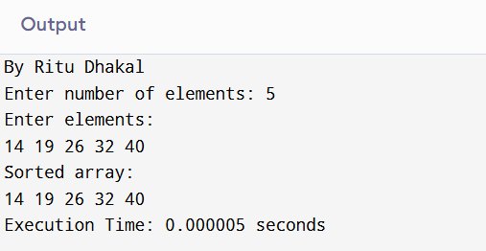
Input / Output 2:
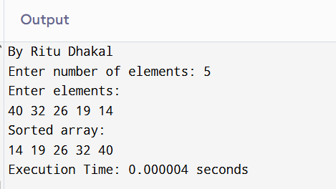
Input / Output 3:
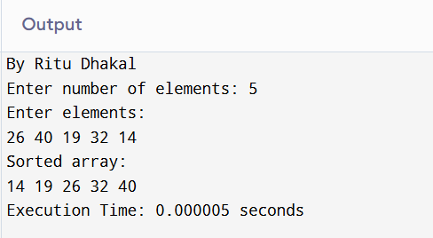

- Write a program in c to sort optimal multiplication cost of given matrices.
Source Code:
#include <stdio.h>
#include <limits.h>
int min(int a, int b) { return (a < b) ? a : b; }
int main()
{
int n, i, l, j, k, q;
int count = 0;
printf("By Ritu Dhakal\n");
printf("Enter number of matrices: ");
scanf("%d", &n);
int p[n + 1];
int m[n + 1][n + 1];
printf("Enter dimensions:\n");
for (i = 0; i <= n; i++)
scanf("%d", &p[i]);
for (i = 1; i <= n; i++)
m[i][i] = 0;
for (l = 2; l <= n; l++)
{
for (i = 1; i <= n - l + 1; i++)
{
j = i + l - 1;
m[i][j] = INT_MAX;
for (k = i; k < j; k++)
{
q = m[i][k] + m[k + 1][j] + p[i - 1] * p[k] * p[j];
count++;
if (q < m[i][j])
m[i][j] = q;
}
}
}
printf("Minimum multiplication cost = %d\n", m[1][n]);
printf("Total RAM operations = %d\n", count);
return 0;
}

Output:
Input / Output 1:
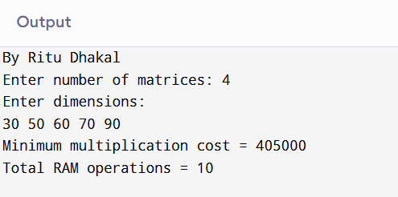

Input / Output 2:
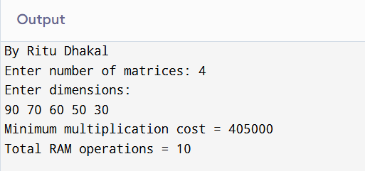

Input / Output 3:
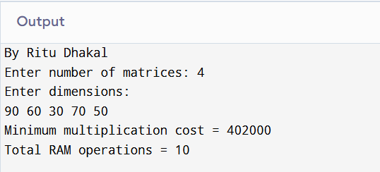

- Write a program in c to sort sequences of jobs and their cost by using job sequencing with deadline.
Source Code:
#include <stdio.h>
int main()
{
int n, i, j, maxd = 0;
printf("\nRitu Dhakal");
printf("\nEnter number of jobs: ");
scanf("%d", &n);
int p[n], d[n], slot[n];
printf("Enter profits:\n");
for (i = 0; i < n; i++)
scanf("%d", &p[i]);
printf("Enter deadlines:\n");
for (i = 0; i < n; i++)
{
scanf("%d", &d[i]);
if (d[i] > maxd)
maxd = d[i];
}
for (i = 0; i < maxd; i++)
slot[i] = -1;
for (i = 0; i < n; i++)
for (j = i + 1; j < n; j++)
if (p[i] < p[j])
{
int t = p[i];
p[i] = p[j];
p[j] = t;
t = d[i];
d[i] = d[j];
d[j] = t;
}
int profit = 0;
for (i = 0; i < n; i++)
for (j = d[i] - 1; j >= 0; j--)
if (slot[j] == -1)
{
slot[j] = i;
profit += p[i];
break;
}
printf("Job sequence:\n");
for (i = 0; i < maxd; i++)
if (slot[i] != -1)
printf("J%d ", slot[i] + 1);
printf("\nTotal Profit = %d\n", profit);
return 0;
}

Output:
Input / Output 1:
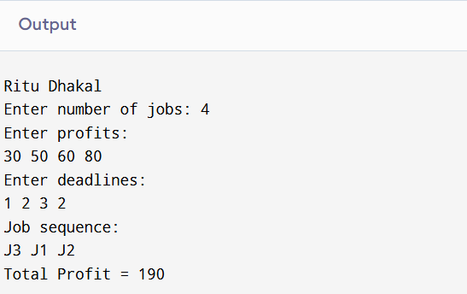

Input / Output 2:
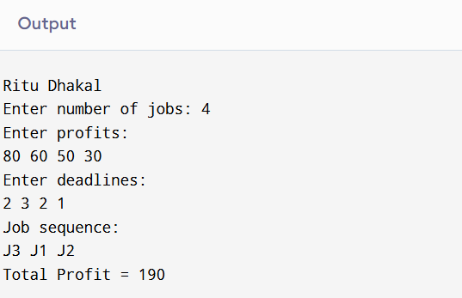

Input / Output 3:
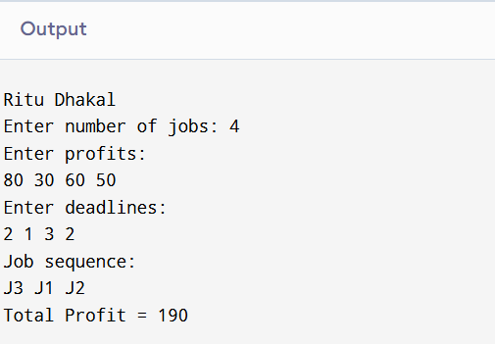
- Write a program in c to find maximum profit by using 0/1 knapsack problem.
Source Code:
#include <stdio.h>
int max(int a, int b) { return a > b ? a : b; }
int main()
{
int n, i, w;
printf("By Ritu Dhakal");
printf("\nEnter number of items: ");
scanf("%d", &n);
int p[n], wt[n];
printf("Enter profits:\n");
for (i = 0; i < n; i++)
scanf("%d", &p[i]);
printf("Enter weights:\n");
for (i = 0; i < n; i++)
scanf("%d", &wt[i]);
printf("Enter capacity: ");
scanf("%d", &w);
int k[n + 1][w + 1];
for (i = 0; i <= n; i++)
for (int j = 0; j <= w; j++)
if (i == 0 || j == 0)
k[i][j] = 0;
else if (wt[i - 1] <= j)
k[i][j] = max(p[i - 1] + k[i - 1][j - wt[i - 1]], k[i - 1][j]);
else
k[i][j] = k[i - 1][j];
printf("Maximum Profit = %d\n", k[n][w]);
return 0;
}

Output:
Input / Output 1:
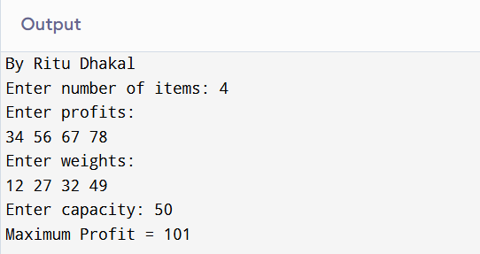
Input / Output 2:
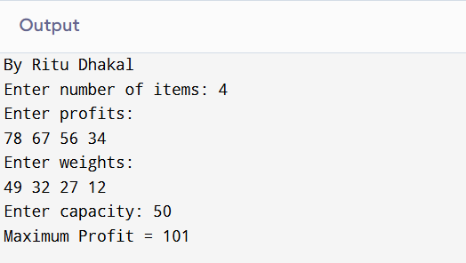
Input / Output 3:
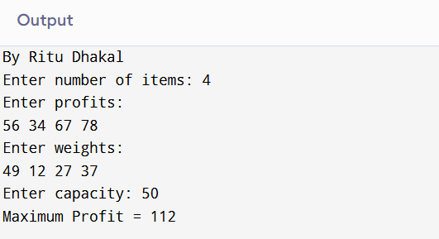
- Write a program in c to find path compression of given text file by using Huffman algorithm.
Source Code:
#include <stdio.h>
#include <stdlib.h>
#define MAX 100
struct node
{
char d;
int f;
struct node *l, *r;
};
struct node *newN(char d, int f)
{
struct node *t = malloc(sizeof(struct node));
t->d = d;
t->f = f;
t->l = t->r = NULL;
return t;
}
void print(struct node *r, char c[], int top)
{
if (r->l)
{
c[top] = '0';
print(r->l, c, top + 1);
}
if (r->r)
{
c[top] = '1';
print(r->r, c, top + 1);
}
if (!r->l && !r->r)
{
c[top] = '\0';
printf("%c : %s\n", r->d, c);
}
}
int main()
{
char text[1000];
int freq[256] = {0}, i = 0;
printf("By Ritu Dhakal");
printf("\nEnter text: ");
scanf("%s", text);
while (text[i])
freq[text[i++]]++;
struct node *arr[MAX];
int n = 0;
for (i = 0; i < 256; i++)
if (freq[i])
arr[n++] = newN(i, freq[i]);
while (n > 1)
{
int m1 = 0, m2 = 1;
if (arr[m1]->f > arr[m2]->f)
{
int t = m1;
m1 = m2;
m2 = t;
}
for (i = 2; i < n; i++)
{
if (arr[i]->f < arr[m1]->f)
{
m2 = m1;
m1 = i;
}
else if (arr[i]->f < arr[m2]->f)
m2 = i;
}
struct node *t = newN('$', arr[m1]->f + arr[m2]->f);
t->l = arr[m1];
t->r = arr[m2];
if (m1 > m2)
{
int x = m1;
m1 = m2;
m2 = x;
}
for (i = m2 + 1; i < n; i++)
arr[i - 1] = arr[i];
n--;
for (i = m1 + 1; i < n; i++)
arr[i - 1] = arr[i];
n--;
arr[n++] = t;
}
char code[100];
printf("Huffman Codes:\n");
print(arr[0], code, 0);
return 0;
}

Output:
Input / Output 1:
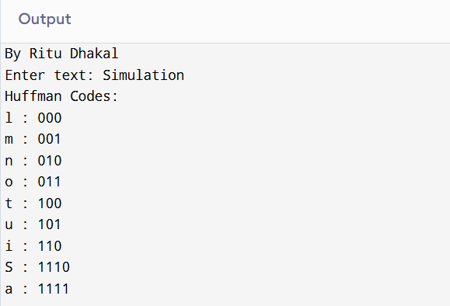

- Write a program in c to find shortest path by using Floyd warshall algorithm (all pair).
Source Code:
#include <stdio.h>
#define INF 99999
int main()
{
int n, i, j, k;
printf("By Ritu Dhakal\n");
printf("Enter number of vertices: ");
scanf("%d", &n);
int graph[n][n];
printf("Enter adjacency matrix (use 99999 for infinity):\n");
for (i = 0; i < n; i++)
for (j = 0; j < n; j++)
scanf("%d", &graph[i][j]);
// Floyd Warshall Algorithm
for (k = 0; k < n; k++)
{
for (i = 0; i < n; i++)
{
for (j = 0; j < n; j++)
{
if (graph[i][k] + graph[k][j] < graph[i][j])
{
graph[i][j] = graph[i][k] + graph[k][j];
}
}
}
}
printf("Shortest distance matrix:\n");
for (i = 0; i < n; i++)
{
for (j = 0; j < n; j++)
{
if (graph[i][j] == INF)
printf("INF ");
else
printf("%d ", graph[i][j]);
}
printf("\n");
}
return 0;
}

Output:
Input / Output 1:
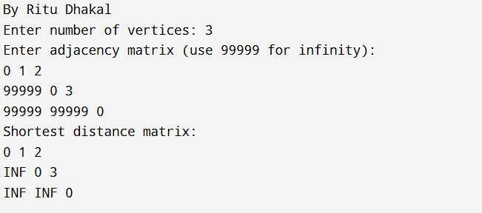

Input / Output 2:
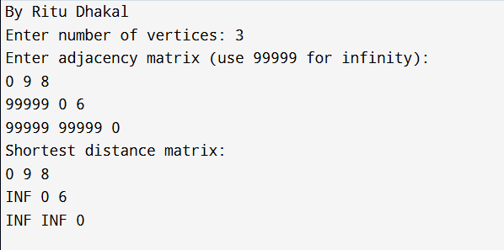
Input / Output 3:

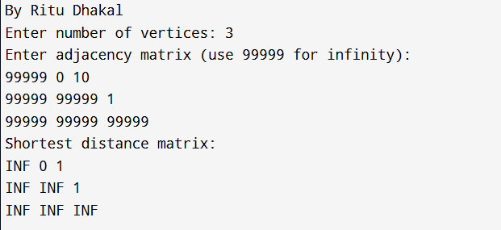

- Write a program in c to find shortest path by using Dijkstra’s algorithm (single source).
Source Code:
#include <stdio.h>
#define INF 9999
int main()
{
int n, i, j, src;
printf("By Ritu Dhakal");
printf("\nEnter number of vertices: ");
scanf("%d", &n);
int g[n][n], dist[n], vis[n];
printf("Enter adjacency matrix:\n");
for (i = 0; i < n; i++)
for (j = 0; j < n; j++)
scanf("%d", &g[i][j]);
printf("Enter source vertex: ");
scanf("%d", &src);
for (i = 0; i < n; i++)
{
dist[i] = INF;
vis[i] = 0;
}
dist[src] = 0;
for (i = 0; i < n - 1; i++)
{
int u = -1;
for (j = 0; j < n; j++)
if (!vis[j] && (u == -1 || dist[j] < dist[u]))
u = j;
vis[u] = 1;
for (j = 0; j < n; j++)
if (!vis[j] && g[u][j] && dist[u] + g[u][j] < dist[j])
dist[j] = dist[u] + g[u][j];
}
printf("Shortest distances:\n");
for (i = 0; i < n; i++)
printf("%d -> %d\n", i, dist[i]);
return 0;
}

Output:
Input / Output 1:
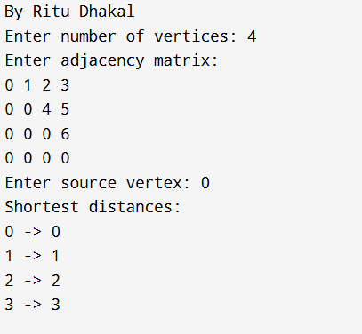

Input / Output 2:
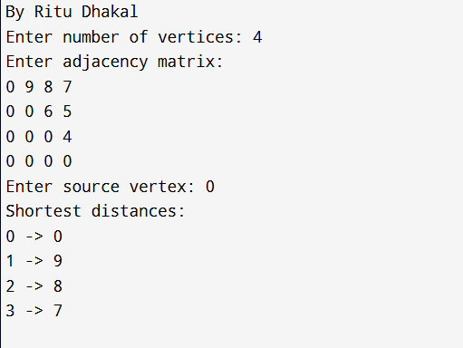

Input / Output 3:
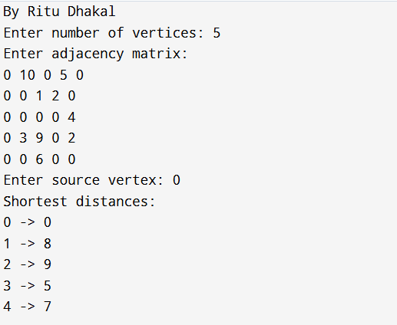

- Write a program in c to find spanning tree of given graph by using Kruskal’s Algorithm.
Source Code:
#include <stdio.h>
#include <stdlib.h>
struct Edge
{
int u, v, w;
};
struct Edge edges[100];
int parent[100];
int find(int i)
{
while (parent[i])
i = parent[i];
return i;
}
int uni(int i, int j)
{
if (i != j)
{
parent[j] = i;
return 1;
}
return 0;
}
int main()
{
int n, e, i, j, a, b, u, v, min, mincost = 0;
printf("By Ritu Dhakal\n");
printf("Enter number of vertices: ");
scanf("%d", &n);
printf("Enter number of edges: ");
scanf("%d", &e);
printf("Enter edges (u v w):\n");
for (i = 0; i < e; i++)
scanf("%d%d%d", &edges[i].u, &edges[i].v, &edges[i].w);
for (i = 0; i < n; i++)
parent[i] = 0;
int count = 0;
while (count < n - 1)
{
min = 99999;
for (i = 0; i < e; i++)
{
if (edges[i].w < min)
{
min = edges[i].w;
a = u = edges[i].u;
b = v = edges[i].v;
j = i;
}
}
u = find(u);
v = find(v);
if (uni(u, v))
{
printf("%d - %d : %d\n", a, b, min);
mincost += min;
count++;
}
edges[j].w = 99999;
}
printf("Minimum cost = %d\n", mincost);
return 0;
}

Output:
Input / Output 1:
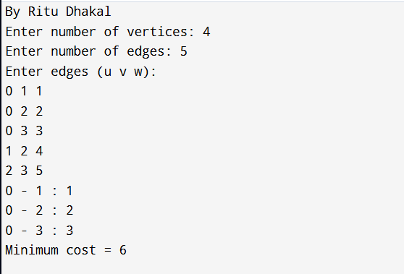

Input / Output 2:
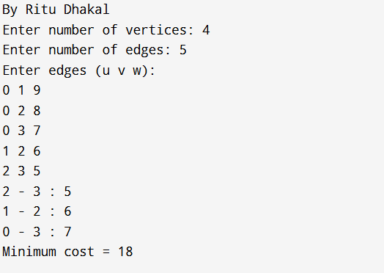
Input / Output 3
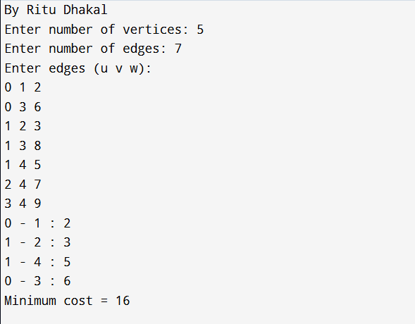

- Write a program in c to find spanning tree of given graph by using Prims algorithm.
Source Code:
#include <stdio.h>
#define MAX 10
#define INF 99999
int main()
{
int n, i, j, u, v, min, mincost = 0;
printf("By Ritu Dhakal\n");
printf("Enter number of vertices: ");
scanf("%d", &n);
int cost[MAX][MAX], visited[MAX] = {0};
printf("Enter adjacency matrix (use 99999 for infinity):\n");
for (i = 0; i < n; i++)
for (j = 0; j < n; j++)
scanf("%d", &cost[i][j]);
visited[0] = 1;
int edges = 0;
while (edges < n - 1)
{
min = INF;
for (i = 0; i < n; i++)
{
if (visited[i])
{
for (j = 0; j < n; j++)
{
if (!visited[j] && cost[i][j] < min)
{
min = cost[i][j];
u = i;
v = j;
}
}
}
}
printf("%d - %d : %d\n", u, v, min);
mincost += min;
visited[v] = 1;
edges++;
}
printf("Minimum cost = %d\n", mincost);
return 0;
}

Output:
Input / Output 1:
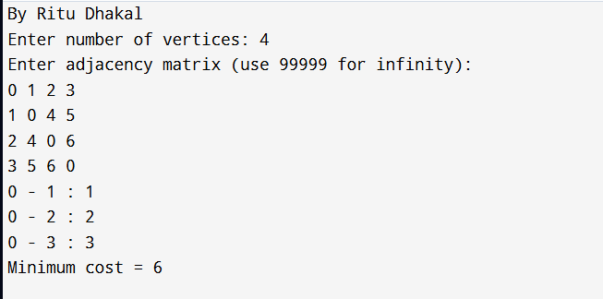

Input / Output 2:
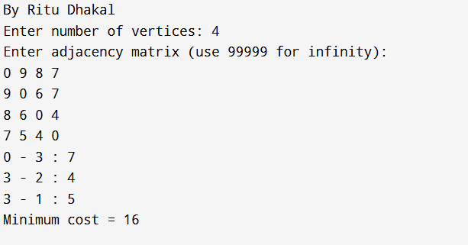

Input / Output 3:
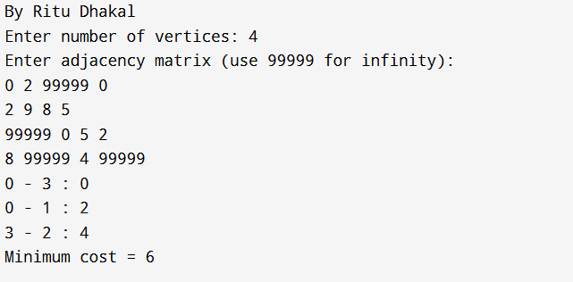

- Write a program in c to find max and min value from given data set by using min-max algorithm.
Source Code:
#include <stdio.h>
int main()
{
int n, i;
printf("By Ritu Dhakal\n");
printf("Enter number of elements: ");
scanf("%d", &n);
int a[n];
printf("Enter elements:\n");
for (i = 0; i < n; i++)
scanf("%d", &a[i]);
int min, max;
if (n % 2 == 0)
{
if (a[0] < a[1])
{
min = a[0];
max = a[1];
}
else
{
min = a[1];
max = a[0];
}
i = 2;
}
else
{
min = max = a[0];
i = 1;
}
while (i < n - 1)
{
if (a[i] < a[i + 1])
{
if (a[i] < min)
min = a[i];
if (a[i + 1] > max)
max = a[i + 1];
}
else
{
if (a[i + 1] < min)
min = a[i + 1];
if (a[i] > max)
max = a[i];
}
i += 2;
}
printf("Minimum value = %d\n", min);
printf("Maximum value = %d\n", max);
return 0;
}
Output:
Input / Output 1:
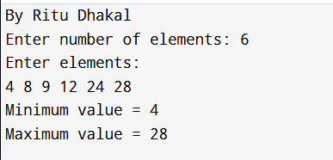
Input / Output 2:
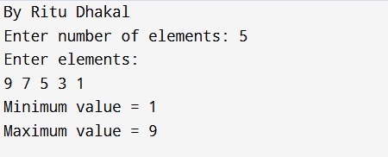
Input / Output 3:
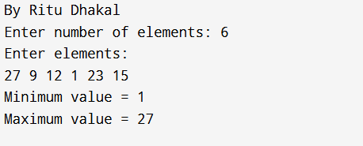

- Write a program in c to select i^{th} smallest element by using selection in expected linear time algorithm.
Source Code:
#include <stdio.h>
#include <stdlib.h>
int partition(int arr[], int low, int high)
{
int pivot = arr[high];
int i = low;
for (int j = low; j < high; j++)
{
if (arr[j] <= pivot)
{
int t = arr[i];
arr[i] = arr[j];
arr[j] = t;
i++;
}
}
int t = arr[i];
arr[i] = arr[high];
arr[high] = t;
return i;
}
int randomPartition(int arr[], int low, int high)
{
int pivotIndex = low + rand() % (high - low + 1);
int t = arr[pivotIndex];
arr[pivotIndex] = arr[high];
arr[high] = t;
return partition(arr, low, high);
}
int quickSelect(int arr[], int low, int high, int k)
{
if (low == high)
return arr[low];
int pi = randomPartition(arr, low, high);
int length = pi - low + 1;
if (length == k)
return arr[pi];
else if (k < length)
return quickSelect(arr, low, pi - 1, k);
else
return quickSelect(arr, pi + 1, high, k - length);
}
int main()
{
int n, i;
printf("By Ritu Dhakal\n");
printf("Enter number of elements: ");
scanf("%d", &n);
int arr[n];
printf("Enter elements:\n");
for (i = 0; i < n; i++)
scanf("%d", &arr[i]);
int k;
printf("Enter k (ith smallest): ");
scanf("%d", &k);
int result = quickSelect(arr, 0, n - 1, k);
printf("%dth smallest element = %d\n", k, result);
return 0;
}

Output:
Input / Output 1:
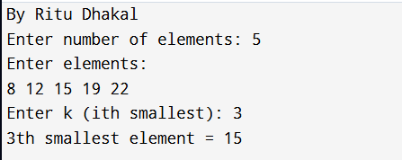
Input / Output 2:
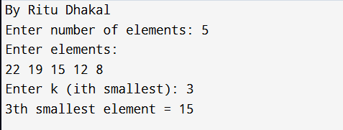
Input / Output 3:
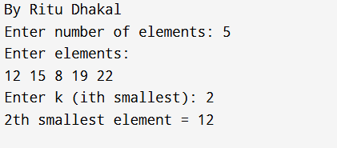
- Write a program in c to select subset sum by using backtracking.
Source Code:
#include <stdio.h>
int x[20]; // solution vector
void subset(int w[], int n, int sum, int k, int curr)
{
if (k >= n)
return; // boundary condition
x[k] = 1;
if (curr + w[k] == sum)
{
printf("Subset: ");
for (int i = 0; i <= k; i++)
{
if (x[i] == 1)
printf("%d ", w[i]);
}
printf("\n");
}
else if (curr + w[k] < sum)
{
subset(w, n, sum, k + 1, curr + w[k]);
}
if (curr < sum)
{
x[k] = 0;
subset(w, n, sum, k + 1, curr);
}
}
int main()
{
int n, sum;
int w[20];
printf("By Ritu Dhakal\n");
printf("Enter number of elements: ");
scanf("%d", &n);
printf("Enter elements:\n");
for (int i = 0; i < n; i++)
scanf("%d", &w[i]);
printf("Enter required sum: ");
scanf("%d", &sum);
subset(w, n, sum, 0, 0);
return 0;
}

Output:
Input / Output 1:

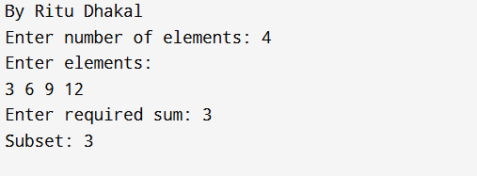

Input / Output 2:

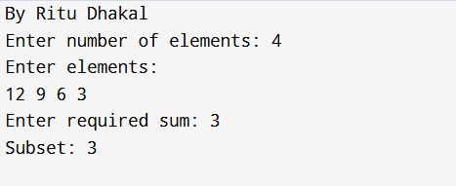

Input / Output 3

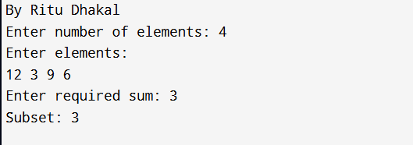

- Write a program in c to select simulate N-queen problem by using backtracking.
Source Code:
#include <stdio.h>
#include <stdlib.h>
int n;
int isSafe(int board[], int row, int col)
{
for (int i = 0; i < row; i++)
{
if (board[i] == col || abs(board[i] - col) == row - i)
return 0;
}
return 1;
}
void printBoard(int board[])
{
printf("Solution:\n");
for (int i = 0; i < n; i++)
{
for (int j = 0; j < n; j++)
{
if (board[i] == j)
printf(" Q ");
else
printf(" . ");
}
printf("\n");
}
printf("\n");
}
void solveNQueen(int board[], int row)
{
if (row == n)
{
printBoard(board);
return;
}
for (int col = 0; col < n; col++)
{
if (isSafe(board, row, col))
{
board[row] = col;
solveNQueen(board, row + 1);
}
}
}
int main()
{
printf("By Ritu Dhakal\n");
printf("Enter number of queens: ");
scanf("%d", &n);
int board[n];
solveNQueen(board, 0);
return 0;
}

Output:
Input / Output 1:
